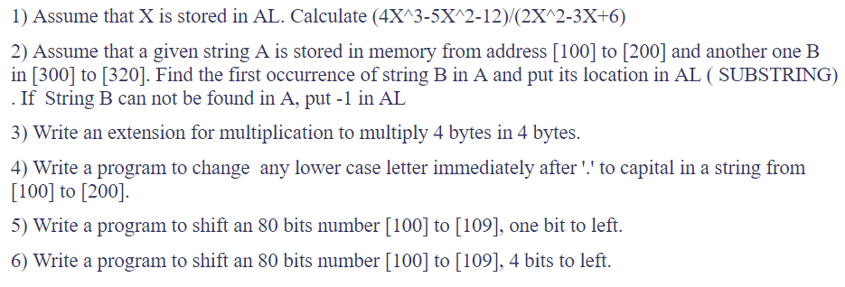

Question 1)

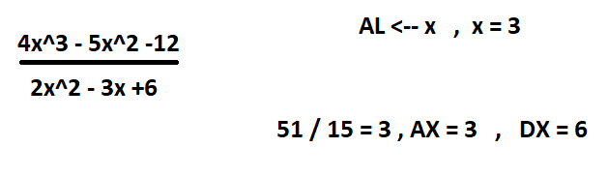

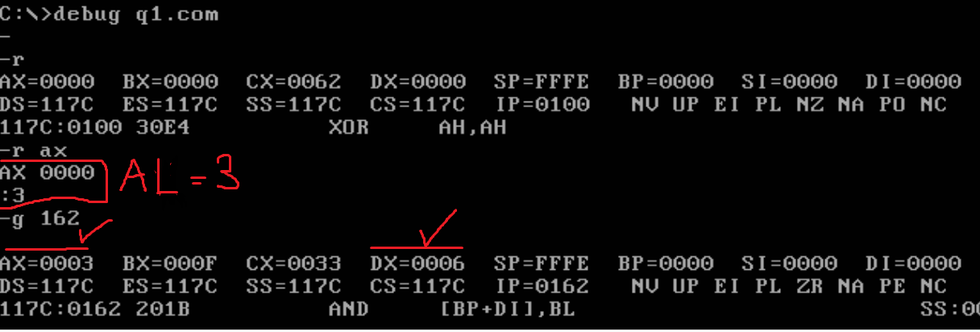

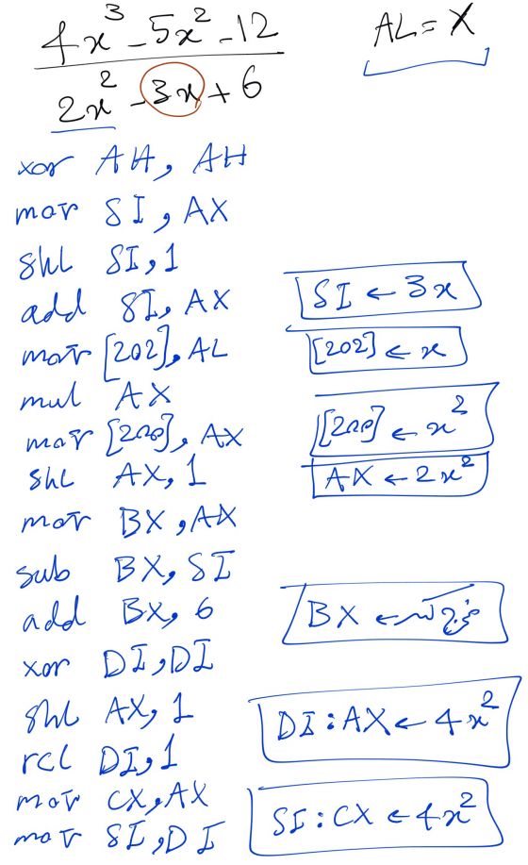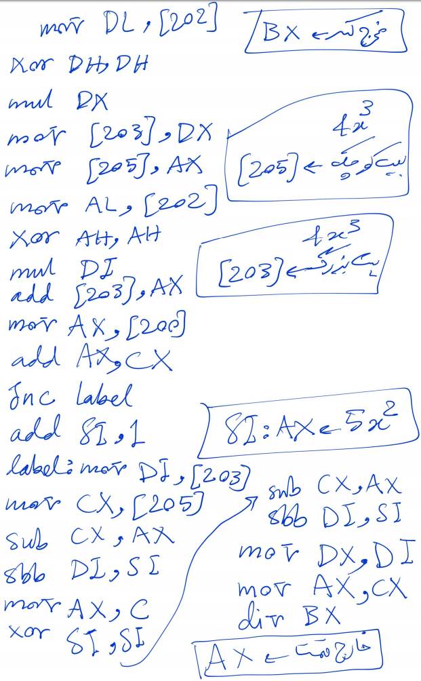

Question 2)

Assembly code:

Mov di,ff   
mov cx,100  
mov dx,300  
start: mov bx,cx  
mov ah,[bx]  
mov bx,dx  
cmp ah,[bx]  
jnz label  
inc dx  
cmp di,ff  
jz label3  
jmp label2  
label3: mov di,cx  
sub di,100  
-jmp label2  
label: mov dx,300  
mov di,ff  
label2: inc cx  
cmp dx,321  
jz end  
cmp cx,201  
jz end  
jmp start  
end:mov ax,di

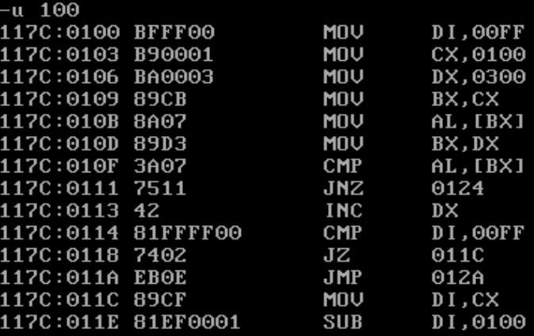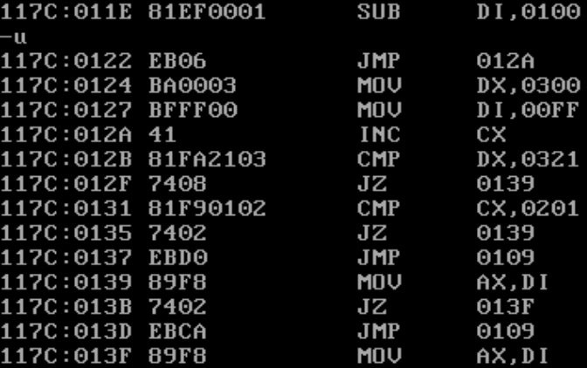

Input and outputs:  
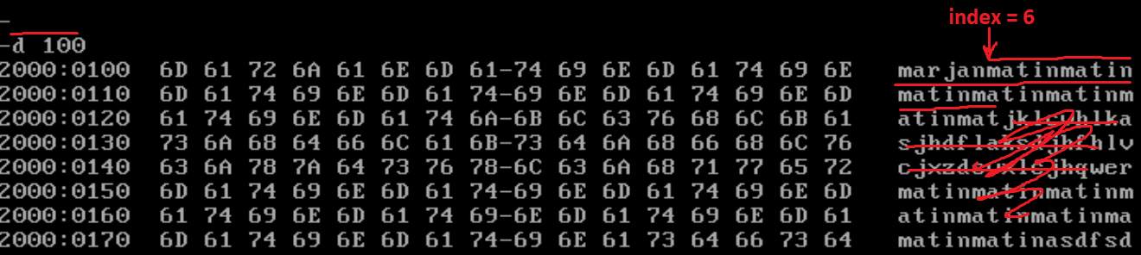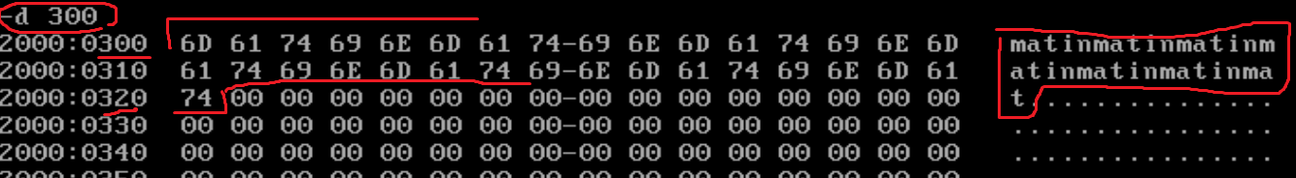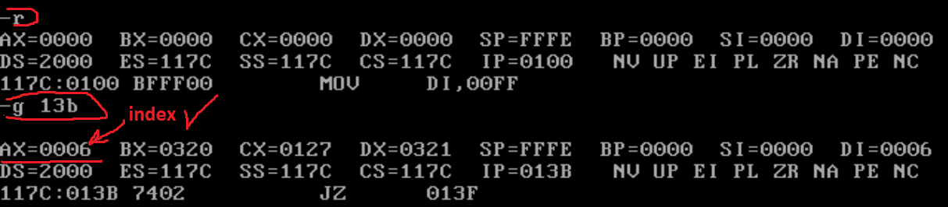

Question 3)

AX:BX  
 *CX:DX  
_______________

BX:DX  
 DX:AX:00  
 BX:CX:00  
 AX:CX:00:00  
______________  
 AX:BX:CX:DX

mov di,dx

mov si,ax

mov ax,bx

mul di

mov [300],ax

mov [100] , dx

mov ax,si

mul di

mov [102], ax

mov [200],dx

mov ax,bx

mul cx

mov [104],ax

mov[202],dx

mov ax,si

mul cx

mov [306],dx

mov [204],ax

xor si,si

xor di,di

mov ax,[100]

add ax,[102]

jnc label

add di,1

label:add ax,[104]

jnc label2

add di,1

label2: mov [302],ax

mov bx,[200]

add bx,[202]

jnc label3

add si,1

label3:add bx,[204]

jnc label4

add si,1

label4: add bx,di

jnc label5

add si,1

label5: mov [304],bx

add [306],si

mov ax,[306]

mov bx,[304]

mov cx,[302]

mov dx,[300]

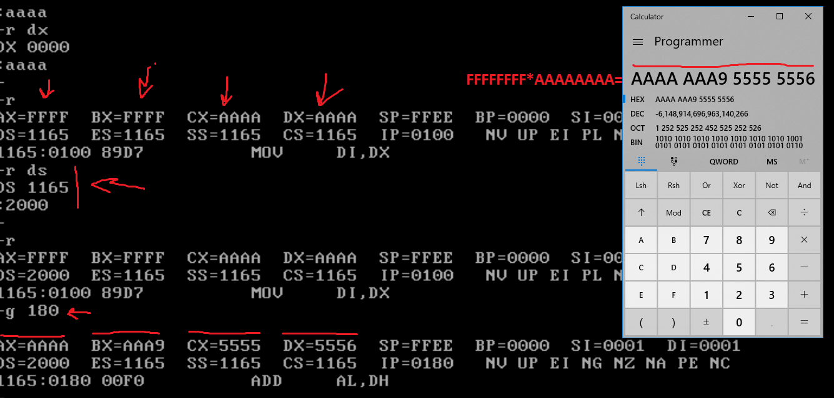

Question 4)  
Input and output: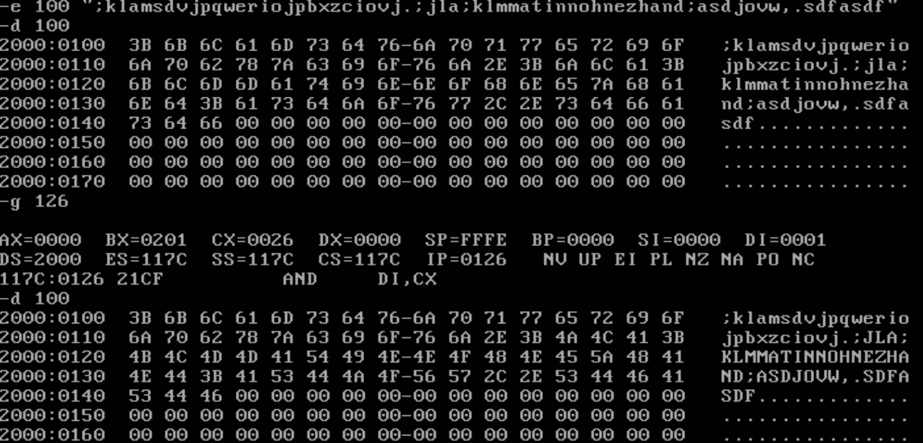

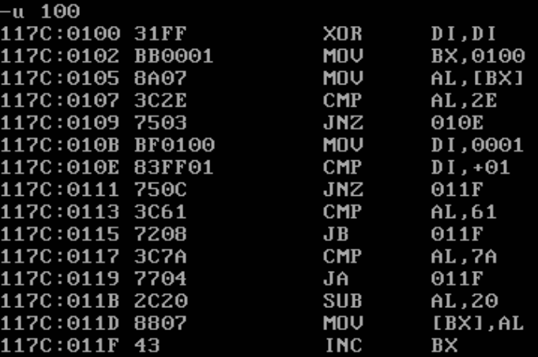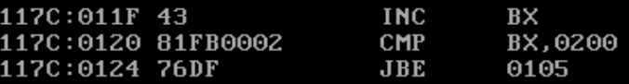

Question 5)

Assembly code:

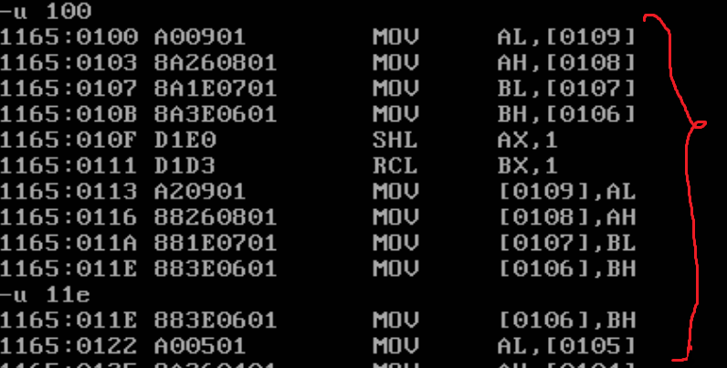

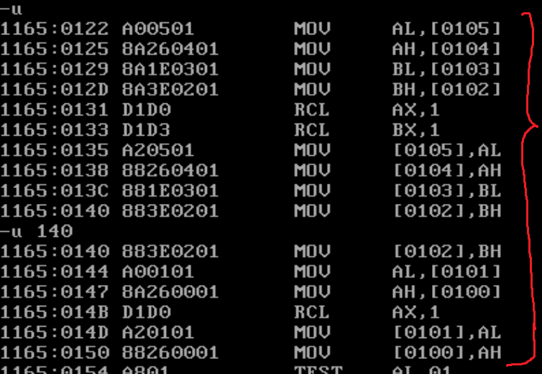

Input and outputs:

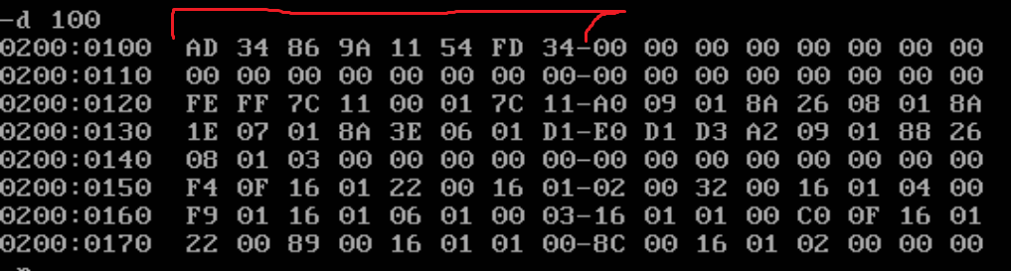

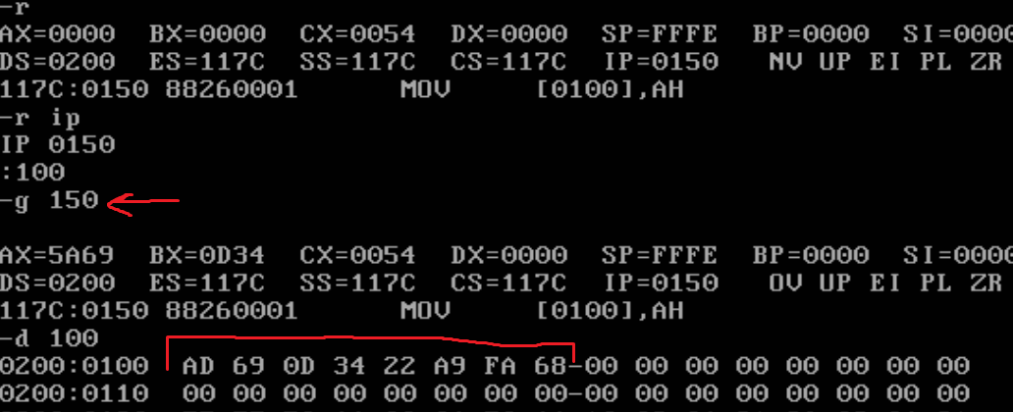

Question 6)

Input and output:

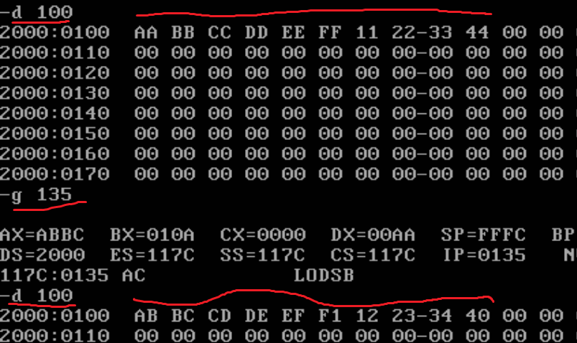

Assembly code:  
